
Mag1010

Author:
Henk-Jan Hoekjen, PhD
Photos:
Mijn Aansluiting.
NEN working group develops NTA ‘Pre-installation of connections with prefabricated meter cabinet’

‘We strive for a fast and effective result’

Sjoerd Loeffen:
‘With a view to
ensuring security of
supply, it is important
to clearly define and
safeguard the working
agreements and
responsibilities
between the parties
involved. ‘

Mag1010 02▪2020


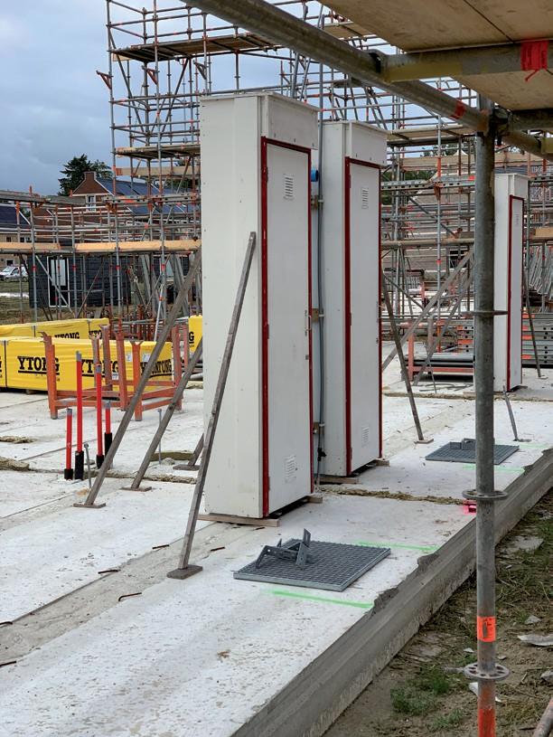

Changing market conditions and construction methods have created a need among various parties to connect new homes to different utility networks at an earlier stage. This can be achieved by installing prefabricated meter cabinets in new-build projects and installing the connections during the structural construction phase.

A group of stakeholders, represented by the Mijn Aansluiting foundation, recently submitted a request to NEN to jointly develop a Dutch Technical Agreement (NTA) for this purpose. Saskia Schulten, consultant at NEN Building & Construction, and Sjoerd Loeffen from Mijn Aansluiting, provide further explanation about this project.

The Netherlands faces a significant housing challenge. Recent research by ABN AMRO’s economic bureau showed that the supply of new homes remains too limited, creating a need for accelerated construction in the coming years. To achieve a faster and more efficient process, improvements can be made in several areas, including the timing of connections to utility networks. Traditionally carried out in the final construction phase, these connections can cause planning issues due to uncertainty around the completion date of new homes.

Plannable
Recently, a group of stakeholders, including energy, water and telecommunications network operators, together with construction companies, developed a joint solution to this challenge through the Mijn Aansluiting foundation. It involves connecting utility services to a prefabricated meter cabinet much earlier in the construction process, up to twenty weeks sooner than usual. This makes the connection date far more predictable and significantly reduces planning changes compared with the traditional approach.

“To ensure security of supply, it is essential to clearly define and safeguard the working agreements and responsibilities between the parties involved in such an early connection,” explains Sjoerd Loeffen of Mijn Aansluiting. “NEN 2768 remains the applicable standard for meter cabinet requirements. However, when a meter cabinet

❐ Early connection of utility services to a prefabricated meter cabinet at an early stage can be carried out up to twenty weeks earlier in the construction process. (Photo: Diepstroeten, Assen)

Mag1010 02▪2020 31

is connected earlier in the construction process, additional aspects arise that are not covered by this standard, according to Loeffen. For example, the meter cabinet must be made wind- and watertight and protected against vandalism and potential damage during construction. These requirements are already common practice for temporary construction connections. “It is essentially about quality assurance and documenting the associated risks,” says Loeffen. “It is also important to clearly define responsibilities. For example, who is responsible if pipes freeze and burst during the winter? These are the kinds of questions we want the NTA to address.”

Fast
The initiators have already prepared a draft outlining the desired requirements for the early installation of utility connections and the use of prefabricated meter cabinets. They then approached NEN with the request to develop this document into an independent and broadly supported agreement. “The intention is to publish the document as a Dutch Technical Agreement (NTA),” says NEN consultant Saskia Schulten. “An NTA is a requirements-based agreement that can be developed relatively quickly. From 26 November to 7 January, other stakeholders had the opportunity to express their interest in joining the working group.”

The first meeting of the NTA working group, held on 9 January, was well attended. In addition to the
approximately ten
organisations involved
in the initiative, around

Saskia Schulten: “The purpose of
developing an NTA is to achieve results quickly.’’

fifteen other parties expressed their interest, including manufacturers of meter cabinet components. There was broad support for developing an NTA. The aim is to publish the NTA this summer. “We now have a draft document that will serve as the basis for our discussions,” says Loeffen.
“The participating parties will be able to submit comments, which we will review and discuss together.”

Alignment
The new NTA will mainly contain procedural agreements for the early installation of utility connections and, since the technical requirements for the connections themselves remain unchanged will fully align with the existing NEN 2768.
“There will be close coordination between the working group and the ‘Metering Spaces’ standards committee, which is responsible for NEN 2768,” says Saskia Schulten. “The purpose of developing an NTA
is to achieve results quickly. If the
scope becomes too broad, you risk
slowing down the process, and
that is exactly what we want
to avoid. The market is
looking for a document
that can be applied in
practice as soon as
possible.” Loeffen fully
agrees. “If it had been
up to us, the document
would have been
completed by the end of 2019.
However, that was not feasible
because it was important to proceed
carefully.”

❐ The meter cabinet must be made wind-and watertight and protected against vandalism and potential damage during construction. (Photo: Tudorpark, Hoofddorp)


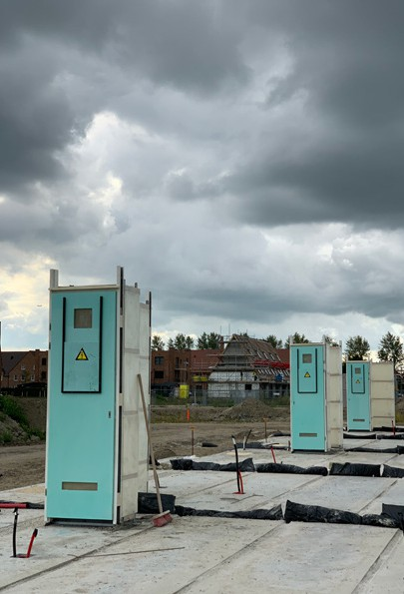

Mag1010 02▪2020 33

